1: <https://www.uno.app/>

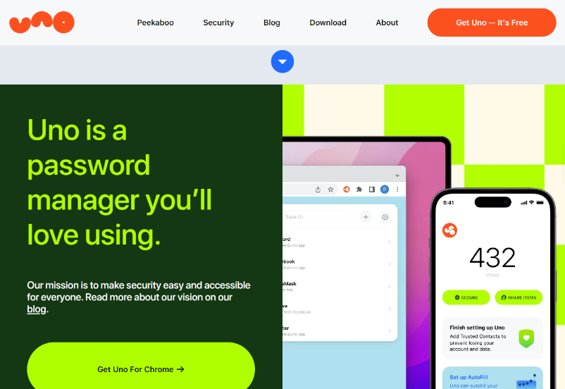I like the use of the large blocks with images and vibrant text, and the way they arrange themselves in desktop and mobile views.

2: <https://www.gran-turismo.com/nz/>

I like when you click a link on the page, it fades to black and back again for a smoother transition. In mobile view the nav bar turns into a burger menu which opens into a full screen navigation menu. When you scroll down, a burger menu appears from the left and slides a small section from the side of the screen.

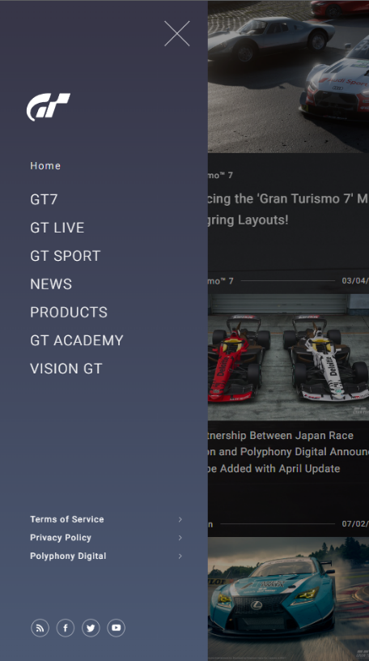

3. <https://stripe.com/sessions>

I like the aesthetic of the rounded containers that scroll above the main background image, and how the stack on top of each other in mobile view like the Uno webpage above. The background image/gif fast forwards and rewinds depending on which way you scroll which I think is a good subtle touch that isn’t easily noticeable.

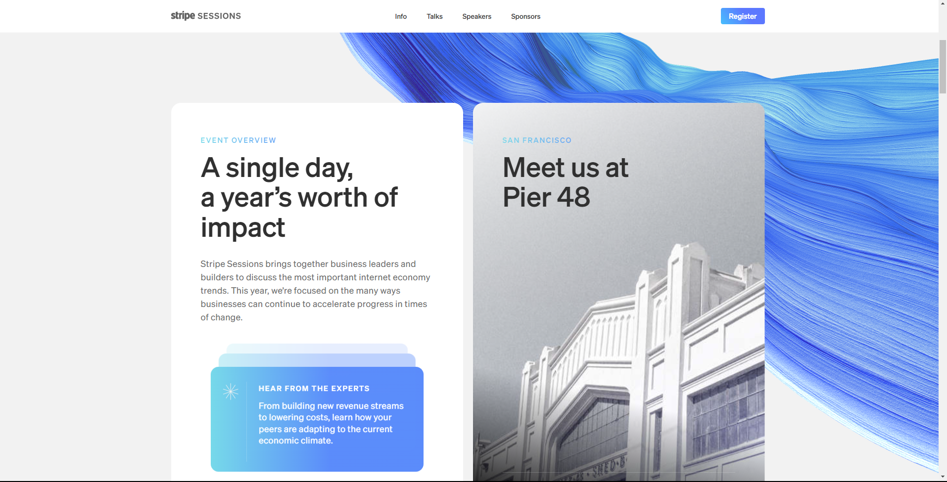

Nav bar changes opacity when scrolled down with JS I assume, buttons also invert colour the same way through changing the class.